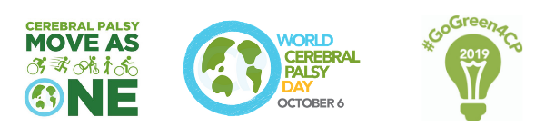

WORLD CEREBRAL PALSY DAY
Sunday, October 6 2019

Media release: World Cerebral Palsy Day 2019

World Cerebral Palsy Day is a movement of people with cerebral palsy (CP), their families, and the organisations that support them, in more than 75 countries.

Its vision is to ensure that children and adults with CP have the same rights, access and opportunities as anyone else in our society.

This year’s celebrations will focus on two key themes – CP Move As One and Go Green 4 CP.

Cerebral Palsy Move As One

In partnership with the Cerebral Palsy International Sports and Recreation Association (CPISRA), this year’s event will promote the benefits of sport and physical activity on the quality of life of people with cerebral palsy and related conditions.

Lauren Milstead, Development Manager, CPISRA says:

“The benefit of sport and physical activity on health and wellbeing is undisputed, and the Paralympics, Special Olympics and Invictus Games have all done a brilliant job at bringing disability sport in to the public eye.

“That said, there is a world of sport and physical activity outside competitive sport and we want to encourage people with CP and related conditions to enjoy the benefits of making sport part of their everyday lives.

“Through CP Move As One, we’re encouraging people with CP, along with their friends and family to do up to 30 minutes of physical activity at 1pm on World Cerebral Palsy Day, and showcase to the world what our community is capable of.”

Go Green 4 CP

As part of #GoGreen4CP more than 170 landmarks around the world are set to light up green on Sunday, 6 October.
Nicole Luongo, Go Green 4 CP Activist and blogger lives with CP, and has secured more than 100 landmarks across the USA, Australia, Canada and Ireland to go green this World Cerebral Palsy Day. Nicole says:

“CP has been in the shadows for far too long.

“It is the most common physical disability in childhood – affecting more than 17 million adults and children worldwide – yet it gets the least media attention.

“I wanted to do my part to change that. The fact that so many places around the United States, and in two other countries will participate in my Go Green for CP in 2019 campaign is a game-changer for CP awareness.”

About Cerebral Palsy

CP is a complex, lifelong disability. It primarily affects movement, but people with CP may also have visual, learning, hearing, speech, epilepsy and intellectual impairments. It can be mild – a weakness in one hand – to severe – where people have little control over movements or speech and may need 24 hour assistance.

Media Enquiries:
Alex McGrath, World Cerebral Palsy Day Manager
E: alex.mcgrath@cerebralpalsy.org.au
T: +61 2 9975 8873
W: worldcpday.org

Facebook, Instagram, Twitter
#WorldCPDay #CPMoveAsOne #GoGreen4CP

