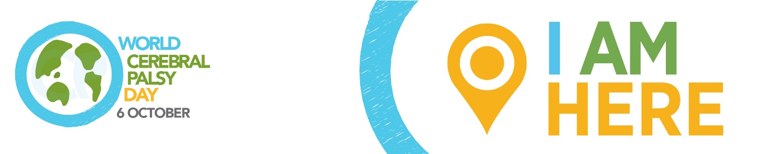

WORLD CEREBRAL PALSY DAY
Sunday October 6 2019

Please adapt to highlight your local civil rights issues/story and spokesperson.

Media release: Civil rights for people with cerebral palsy

Cerebral palsy (CP) is the most common physical disability in childhood and is also one of the least understood. There are over 17 million people living with CP and 350 million family, friends and supporters who care about them.

World Cerebral Palsy Day is a movement of people with cerebral palsy and their families, and the organisations that support them, in more than 75 countries.

Its vision is to ensure that children and adults with cerebral palsy (CP) have the same rights, access and opportunities as anyone else in our society.

Alex McGrath, World CP Day Manager explains, “In many countries, people with CP are ‘invisible’. They live out of sight, out of mind and out of options”.

“We talk to people with CP, their families and organisations around the world and find incredibly frustrating similarities. The same issues keep coming up again and again.”
“But the good news is we also hear about the success stories – individuals and organisations who are creating positive change in their communities and are willing to share their experiences, tools and tips. Our mission is to highlight the issues, unearth the success stories and encourage people to take action in their communities”.

Civil rights

The global struggle for civil and human rights is ongoing but, even in societies where the most progress has been made, many people with CP lag well behind the majority.

At one end of the spectrum are governments that are struggling to meet the basic rights of all its citizens, so the population of people with CP are even more vulnerable. People with CP can face stigma and superstition that limits theirs’ and their families’ futures.

At the other end of the spectrum are governments that have enshrined the rights of people with a disability, but where there are still subtle, systemic barriers to full participation and inclusion.

In the middle are a range of well-intentioned countries that have made declarations of intent but never quite fulfil the resolve in practice.

“We need to pool our resources to ensure that government officials at the local, regional and national level take concrete action to guarantee basic rights, full citizenship and individual opportunities for people with CP”, Alex declared.

How you/your organisation is taking action on civil rights

World CP Day

It is time to close the gap between the everyday circumstance and the very real potential of those living with CP. To show your support, visit World CP Day website worldcpday.org, sign up for News or, even better, Join Us on the Map!

Media Enquiries:
Alex McGrath, World Cerebral Palsy Day Manager
E: alex.mcgrath@cerebralpalsy.org.au
T: +61 2 9975 8873
W: worldcpday.org

