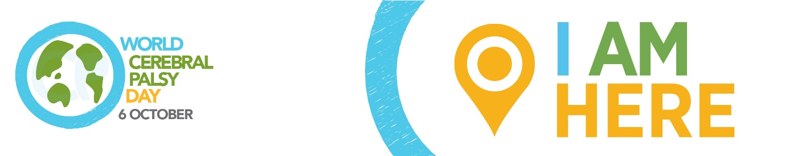

WORLD CEREBRAL PALSY DAY
Sunday October 6 2019

Please adapt to highlight your local contribution issues/story and spokesperson.

Media release: Contributing lives for people with cerebral palsy

World Cerebral Palsy Day is a movement of people with cerebral palsy (CP) and their families, and the organisations that support them, in more than 75 countries.

Its vision is to ensure that children and adults with CP have the same rights, access and opportunities as anyone else in our society.

Alex McGrath, World CP Day Manager explains: “Cerebral palsy is the most common physical disability in childhood and is also one of the least understood. There are over 17 million people living with CP and 350 million family, friends and supporters who care about them.”

“We talk to people with CP, their families and organisations around the world and find incredibly frustrating similarities. The same issues keep coming up again and again.

“One of those issues is about people’s ability to lead contributing lives. Each of us has a unique ability to contribute economically, artistically, socially and/or politically. Not being able to make that contribution is not just a matter of personal loss, it is a matter of robbing our entire society and culture of something that is essential to its ability to flourish.”

“But the good news is we also hear about the success stories – individuals and organisations who are creating positive change in their communities and are willing to share their experiences, tools and tips. Our mission is to highlight the issues, unearth the success stories and encourage people to take action in their communities.”

Contribution

Perhaps the single greatest loss in the lives of people with CP—and to the communities in which we live—is the fact that so many members of our community are simply unable to live to their full potential. To make their contribution.

An individual’s identity is closely linked to their contribution – the value that they can add to the world. Everyone needs a story to tell about ‘what they did with their day’.

This issue does not just revolve around the stereotypical definitions of contribution, such as having a job – although the ability to do so is certainly an important issue in the lives of many of our community members.

Members of the CP community have talents and contributions to make in the areas of art, science, education, and politics. As poets or teachers. As public speakers or engineers. As painters or parents. The kind of contributions that don’t just have a lasting impact in the life of a person with CP, but that add profound value to our society.

We must make a commitment to ensure that all people with CP are able to make their contribution. Because it is a matter of personal justice. Because it is a matter of ensuring our community receives the important benefit of that contribution.

How you/your organisation helping people with CP to contribute

World CP Day

It is time to close the gap between the everyday circumstance and the very real potential of those living with CP. To show your support, visit World CP Day website worldcpday.org, sign up for News or, even better, Join Us on the Map!

Media Enquiries:
Alex McGrath, World Cerebral Palsy Day Manager
E: alex.mcgrath@cerebralpalsy.org.au
T: +61 2 9975 8873
W: worldcpday.org

