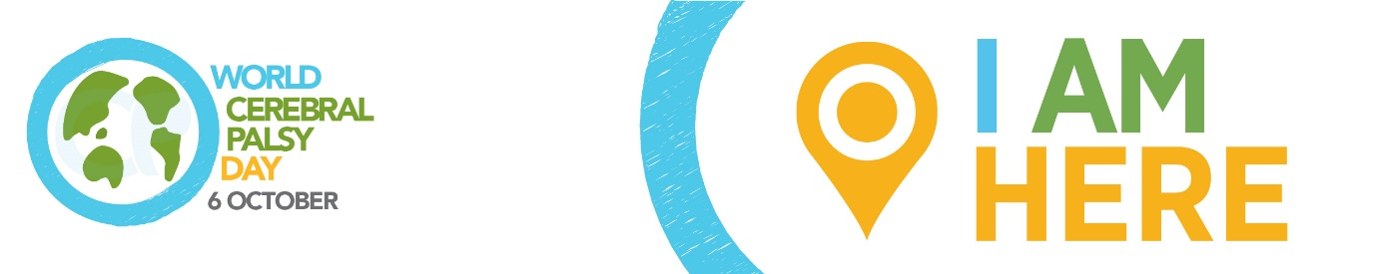

WORLD CEREBRAL PALSY DAY
Sunday October 6 2019

Please adapt to highlight your local education issues/story and spokesperson.

Media release: Education for children and young people with cerebral palsy

World Cerebral Palsy Day is a movement of people with cerebral palsy (CP) and their families, and the organisations that support them, in more than 75 countries.

Its vision is to ensure that children and adults with CP have the same rights, access and opportunities as anyone else in our society.

Alex McGrath, World CP Day Manager explains: “Cerebral palsy is the most common physical disability in childhood and is also one of the least understood. There are over 17 million people living with CP and 350 million family, friends and supporters who care about them.”

“We talk to people with CP, their families and organisations around the world and find incredibly frustrating similarities. The same issues keep coming up again and again, and one of those issues is education. We found that children and young people with CP do not have equal access to education in countries around the world.”

“But the good news is we also hear about the success stories – individuals and organisations who are creating positive change in their communities and are willing to share their experiences, tools and tips. Our mission is to highlight the issues, unearth the success stories and encourage people to take action in their communities.”

“We want to work together to help all educators create an experience that will encourage the broader community to embrace people with CP, and provide an education to members of the CP community that is equal to that of every other citizen of the societies in which we live.”

Education

Access to education is not just a human right, it is the single greatest predictor of a fulfilling life, and perhaps the most important measure of a society’s social and economic potential.

Without that access, a future of living separate from society becomes cemented at an early age. But access is not enough.

In fact, access without expertise can actually increase the chance for social stigma without increasing the opportunity to learn. Too many members of the CP community—whether in elementary or graduate-level learning environments—find themselves relegated to the back of the classroom without appropriate support to ensure they learn. Others can become so much of the focus of an inexperienced teacher’s attention that, sadly, other class members and their families can develop resentment.

The key to success is enough qualified educators and support specialists to ensure that every person receives the education they deserve in the way that best ensures they are able to learn.

This challenge extends beyond the classroom to all forms of learning. From access to knowledge through the internet, to the specialised training that can help a person get a new job or promotion.

How you/your organisation is taking action on public awareness

World CP Day

It is time to close the gap between the everyday circumstance and the very real potential of those living with CP. To show your support, visit World CP Day website worldcpday.org, sign up for News or, even better, Join Us on the Map!

Media Enquiries:
Alex McGrath, World Cerebral Palsy Day Manager
E: alex.mcgrath@cerebralpalsy.org.au
T: +61 2 9975 8873
W: worldcpday.org
