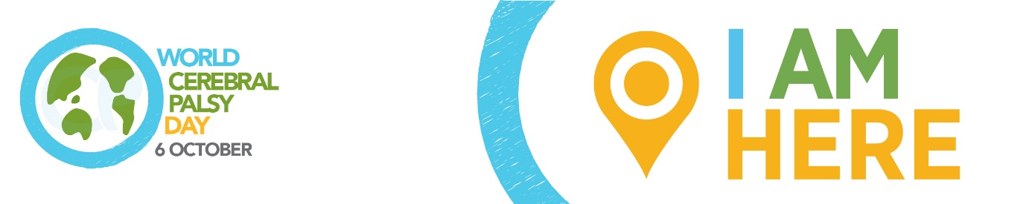

WORLD CEREBRAL PALSY DAY
Sunday October 6 2019

Please adapt to highlight your local medical-therapeutic issues/story and spokesperson.

Media release: Medical and Therapeutic

World Cerebral Palsy Day is a movement of people with cerebral palsy (CP) and their families, and the organisations that support them, in more than 75 countries.

Its vision is to ensure that children and adults with CP have the same rights, access and opportunities as anyone else in our society.

Alex McGrath, World CP Day Manager explains: “Cerebral palsy is the most common physical disability in childhood and is also one of the least understood. There are over 17 million people living with CP and 350 million family, friends and supporters who care about them.”

“We talk to people with CP, their families and organisations around the world and find incredibly frustrating similarities. The same issues keep coming up again and again.”

“Too few doctors and therapists have the latest information on diagnosing cerebral palsy, let alone the best available evidence on its treatment”.
“But the good news is that we are finding researchers and clinicians who want to share this knowledge and some with initiatives that will not only inform the medical and therapy community, but empower people with CP and their families to insist on the most effective treatments.”

Medical-Therapeutic Issues

To understand the medical/therapeutic issues surrounding people with cerebral palsy (CP), it is best to divide the discussion the three basic building blocks of care: cause, diagnosis and treatment.

Addressing the cause
There is no single cause of CP, rather, a sequence of events, either before, during or after birth that can lead to an injury in a baby’s developing brain. For most babies born with CP in developed countries, the cause remains unknown. Only a very few are as a result of complications at birth (e.g. asphyxia or lack of oxygen).

In the developing world, the number of preventable cases of CP is much higher and could be addressed if mothers and babies had better access to good medical care, and if primary clinicians had access to better information and tools. That is a problem that we can begin to solve right now.

Early diagnosis
There is no single test that offers a definitive diagnosis of CP. Effective diagnosis may involve a combination of tests such as a CT scan or MRI (which are not widely available) and clinical assessment (for which many primary care givers have not been trained). The net impact is that CP is often diagnosed too late. That means that children miss the vital care and motor enrichment during the critical months of brain development after birth and, possibly, the opportunity to lessen the impact of CP.

There is a hope, with a new way to assess the risk of CP in infants as young as 3 months of age called the General Movements Assessment. More details about it on the World CP Day website.

Effective treatment
While many governments offer healthcare for all, access to specialised therapy is not universally available. There are very specific physical, occupational, speech and cognitive therapies that have proven most successful for people with CP. Even when the condition is diagnosed early, too many of our community members lack access to the therapies they need. Not just during monthly, weekly or daily clinical visits, but for the other 99% of a person’s life when they are at home with family members and caregivers.

Clearly, more progress must be made in CP research, but we can also have an immediate impact by simply providing better information to the critical medical and therapeutic specialists that are on the front line of care. Tools and guides that translate evidence for these professionals (and people with CP and family members) that cut through the noise and provide clarity about CP diagnosis and treatment are vitally important.

How you/your organisation is taking action on medical/therapeutic issues

World CP Day

It is time to close the gap between the everyday circumstance and the very real potential of those living with CP. To show your support, visit World CP Day website worldcpday.org, sign up for News or, even better, Join Us on the Map!

Media Enquiries:
Alex McGrath, World Cerebral Palsy Day Manager
E: alex.mcgrath@cerebralpalsy.org.au
T: +61 2 9975 8873
W: worldcpday.org

