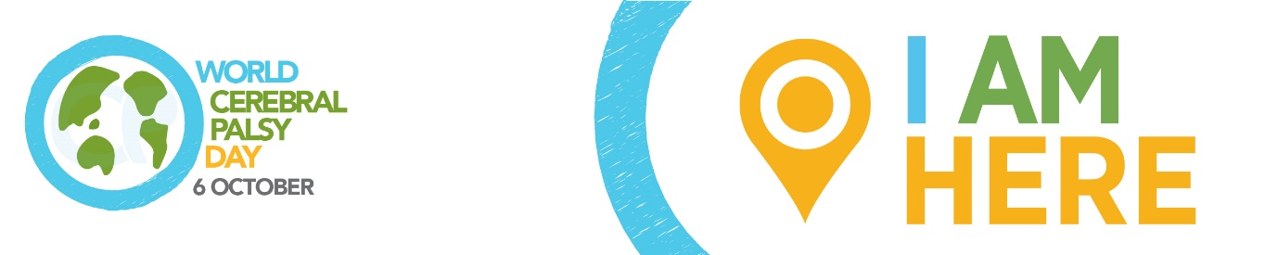

WORLD CEREBRAL PALSY DAY
Sunday October 6 2019

Please adapt to highlight your local public awareness issues/story and spokesperson.

Media release: Public awareness of cerebral palsy

World Cerebral Palsy Day is a movement of people with cerebral palsy (CP) and their families, and the organisations that support them, in more than 75 countries.

Its vision is to ensure that children and adults with CP have the same rights, access and opportunities as anyone else in our society.

Alex McGrath, World CP Day Manager explains: “Cerebral palsy is the most common physical disability in childhood and is also one of the least understood. There are over 17 million people living with CP and 350 million family, friends and supporters who care about them.”

“But In many countries, people with CP are ‘invisible’. They live out of sight, out of mind and out of options.”

“We talk to people with CP, their families and organisations around the world and find incredibly frustrating similarities. The same issues keep coming up again and again.”

“But the good news is we also hear about the success stories – individuals and organisations who are creating positive change in their communities and are willing to share their experiences, tools and tips. Our mission is to highlight the issues, unearth the success stories and encourage people to take action in their communities.”

Public awareness

CP is a complex, lifelong disability. It primarily affects movement, but people with CP may also have visual, learning, hearing, speech, epilepsy and intellectual impairments. It can be mild – a weakness in one hand – to severe – where people have little control over movements or speech and may need 24 hour assistance.

“People with CP across the world tell us that they face a range of responses in their communities,” explained World CP Day Manager, Alex McGrath.

“A young woman with CP recently told me: ‘People either underestimate us, or overestimate us’. It may be through well-meaning but misguided sympathy or pity, which serves to undermine a person’s autonomy and independence. Or, it can be people who want to make a ‘hero’ out of someone who just wants to lead an ordinary life.”

In many countries, people with CP face superstition and they and their families live a life of exclusion. Other countries seem inclusive on the surface, but have a population who are not quite sure what to say to someone living with CP, so don’t engage at all.

There is nothing to be gained in blaming people for their ignorance about CP. Instead, World CP Day is working to put an end to it. Around the world individuals and organisations are working to dispel the myths and break down the barriers to ensure that people with CP, and their families, can live full, contributing lives.

How you/your organisation is taking action on public awareness

World CP Day

It is time to close the gap between the everyday circumstance and the very real potential of those living with CP. To show your support, visit World CP Day website worldcpday.org, sign up for News or, even better, Join Us on the Map!

Media Enquiries:
Alex McGrath, World Cerebral Palsy Day Manager
E: alex.mcgrath@cerebralpalsy.org.au
T: +61 2 9975 8873
W: worldcpday.org

