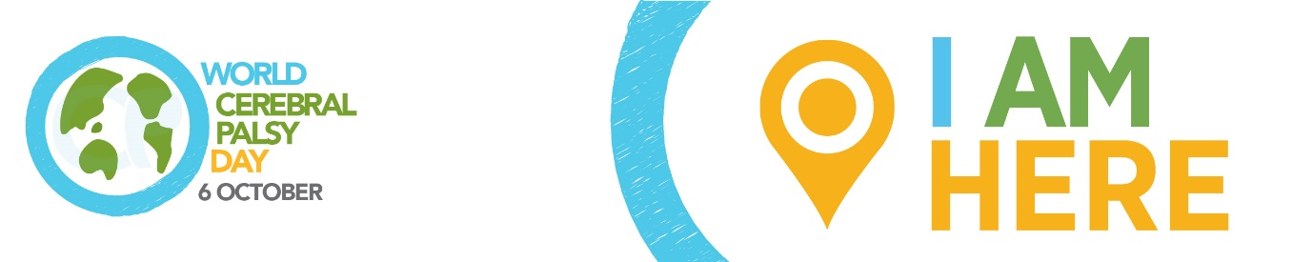

WORLD CEREBRAL PALSY DAY
Sunday October 6 2019

Please adapt to highlight your local quality of life issues/story and spokesperson.

Media release: Quality of life for people living with cerebral palsy

World Cerebral Palsy Day is a movement of people with cerebral palsy (CP) and their families, and the organisations that support them, in more than 75 countries.

Its vision is to ensure that children and adults with CP have the same rights, access and opportunities as anyone else in our society.

Alex McGrath, World CP Day Manager explains: “Cerebral palsy is the most common physical disability in childhood and is also one of the least understood. There are over 17 million people living with CP and 350 million family, friends and supporters who care about them.”

“We talk to people with CP, their families and organisations around the world and find incredibly frustrating similarities. The same issues keep coming up again and again.”
“One of those issues is what we call quality of life. It’s about helping people thrive, and find enjoyment and fulfilment in life.

“We are hearing about some wonderful success stories – individuals and organisations who are creating positive change in their communities and are willing to share their experiences, tools and tips. Our mission is to highlight the issues, unearth the success stories and encourage people to take action in their communities.”

Quality of Life

Access to medical and therapeutic care available is essential to helping people with CP live the best possible life. But the most specialised doctors and therapists will be the first to admit that even the best possible medical intervention can only go so far.

CP is not just a day-by-day reality it has a moment-by-moment impact in people’s lives—not just in the lives of those with CP, but among families and caregivers, as well. Whether or not one of our community members has a fulfilling life has just as much to do with the quality of that life.

Access to tools and products
There are, of course, many specific products—including non-spill cups, the ability to type on a computer using an eye scanner, or an electric wheelchair—that can have a powerful effect on the quality of life of our community members. The most recent World CP Day competition, for example, illustrated the need for a safer living environment by suggesting the possibility of a ‘sponge house’. But the needs of most of our community members are much more extensive and basic. What, for example, is to be done when a person who lives in a country in which adult diapers (nappies) are simply not available?

Access to information
Where can a parent go to get advice about the best way to care for their child? Where can a traveller find information about the most accessible tourist attractions? Where can a man with CP learn to become a writer for the local paper? Where can a teenager get access to the film, Margarita with a Straw or Enter the Faun, to find the inspiration to live their own life? Where can a woman get advice about how to become a stand-up comedian? The sea of needs, and the questions that arise from those needs, are vast. But it almost assured that they have been asked and answered by other members of our global community.

Access to support
Sometimes an ‘advanced’ society has become that way at the expense of the kind of familial and community networks that have historically supported individuals and families. In other societies, there are no support networks because of the stigma surrounding disability or the inability of people to connect across physical and digital divides. We have the chance to build supportive communities—first online, and eventually ‘on the ground’—that can help improve the social, economic and personal quality of life for people with CP.

How you/your organisation is taking action to improve the lives of people with CP and their families

World CP Day

It is time to close the gap between the everyday circumstance and the very real potential of those living with CP. To show your support, visit World CP Day website worldcpday.org, sign up for News or, even better, Join Us on the Map!

Media Enquiries:
Alex McGrath, World Cerebral Palsy Day Manager
E: alex.mcgrath@cerebralpalsy.org.au
T: +61 2 9975 8873
W: worldcpday.org

